**Boxify : Sales Analysis and Inventory** **Insights – Project**

Effective inventory management is essential for businesses to maintain optimal stock levels, minimize carrying costs, and meet customer demand. As a data analyst, your task is to analyse a sales dataset, extract valuable insights, and provide inventory-driven recommendations to enhance inventory management practices. Conducted an end-to-end data analysis project focused on sales and inventory management, encompassing data collection, cleaning, and preprocessing. Performed exploratory data analysis to identify sales trends, top-performing products, and inventory insights. Created interactive Tableau dashboards and data visualizations to deliver actionable recommendations, improve decision-making, and enhance inventory efficiency."

**Objectives:**

1. Analyse the provided sales dataset to understand sales trends, stock levels, and product performance.
2. Identify popular products, low-stock items, and sales patterns over time.
3. Generate actionable recommendations for improving inventory management efficiency.

**Tasks/Activities List:**

1. Data Collection and Preprocessing**:**
   * **Obtain the sales dataset from the provided source:**[**Sales Analysis Dataset**](https://kh3-ls-storage.s3.us-east-1.amazonaws.com/Data%20Analyst%20Project/Boxify%20Dataset%20-%20Data%20Analyst%20Bootcamp.csv).

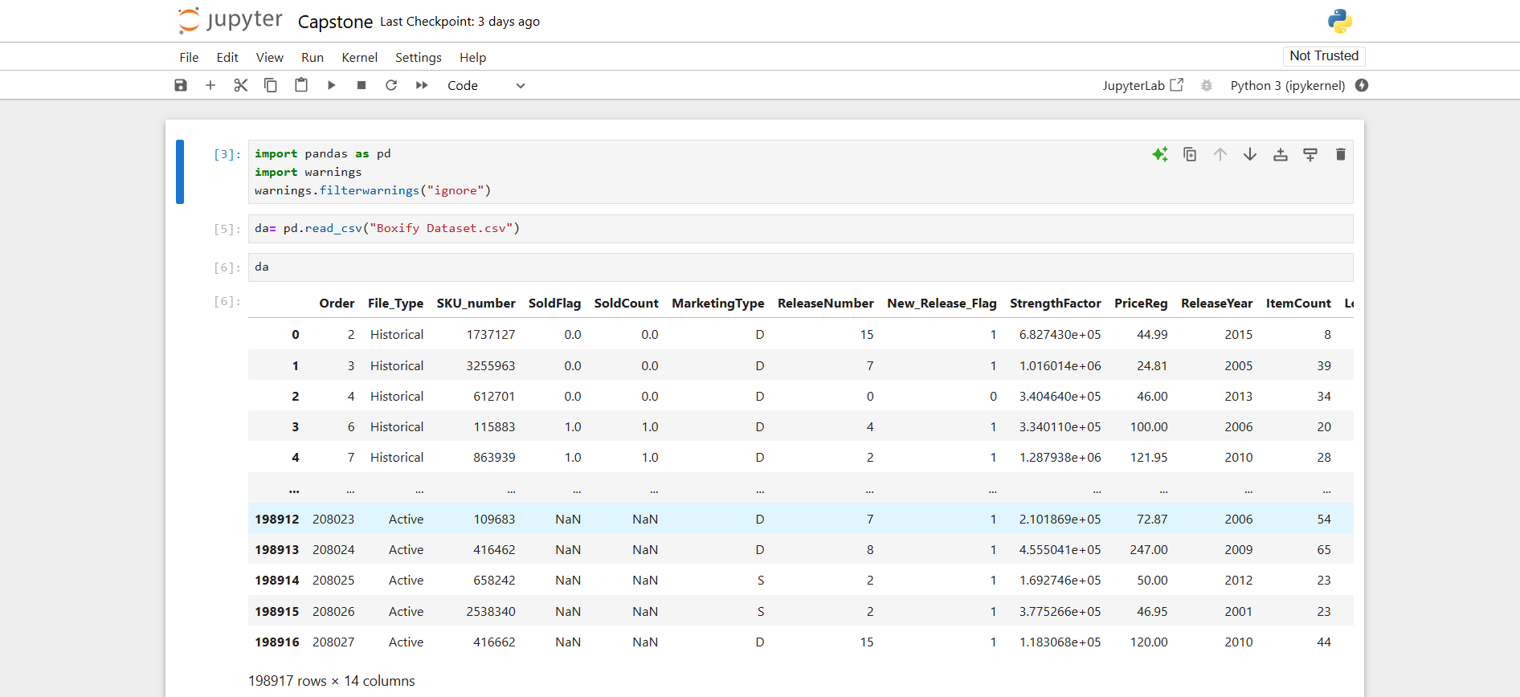

* + **Clean and preprocess the data to handle missing values and inconsistencies.**

1. Exploratory Data Analysis (EDA):

* **Analyse sales trends and variations over time.**

This shows the variation over time and trend over time

* **Identify top-selling products and categories**.

* **Investigate stock levels and low-stock items**.

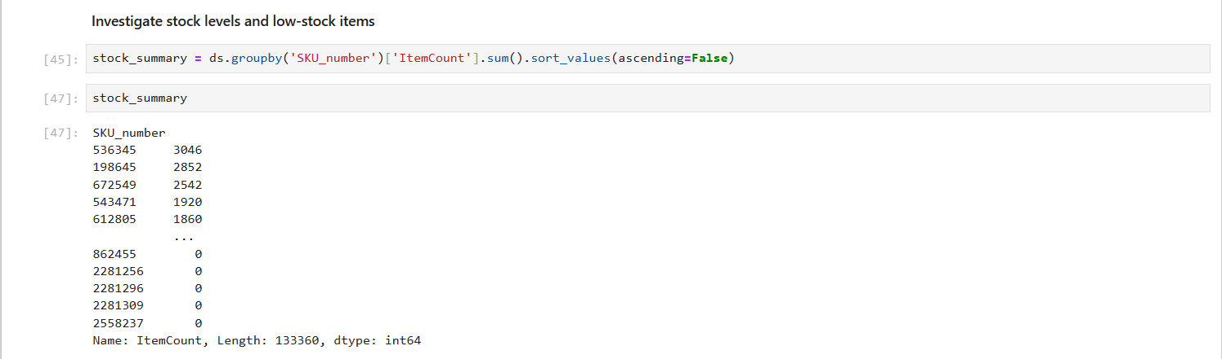

1. Inventory Insights and Recommendations:

**KPI**

**. Calculate key performance indicators (e.g., inventory turnover, stock-to-sales ratio, reorder points).**

* **Provide actionable recommendations to optimize inventory management based on sales patterns.**

**1. Adjust Safety Stock Levels**

**Insight:** Identify products with fluctuating or high demand using historical sales trends.

**Action:** Maintain higher safety stock levels for these items to prevent stockouts during demand spikes.

**Benefit:** Improved customer satisfaction and reduced lost sales opportunities.

**2. Focus on Top-Performing Products**

**Insight:** Top-selling products contribute significantly to revenue.

**Action:** Allocate more inventory to these products and prioritize their availability.

**Benefit:** Higher sales and improved profitability.

**3. Automate Low-Stock Alerts**

**Insight:** Track low-stock items frequently and automate alerts when inventory reaches reorder points.

**Action:** Set up an automated inventory management system to trigger restocking notifications.

**Benefit:** Proactive replenishment prevents interruptions in the supply chain.

**4. Optimize Inventory Turnover**

**Insight:** Calculate and monitor inventory turnover rates to assess efficiency.

**Action:** Rotate inventory regularly, focusing on products with slower turnover rates.

**Benefit:** Reduced holding costs and minimized risk of obsolescence.

1. Data Visualization:

**Create interactive and informative visualizations (e.g., line charts, bar plots) to present sales trends and inventory metrics.**

* 1. **Analyse sales trends and variations over time.**

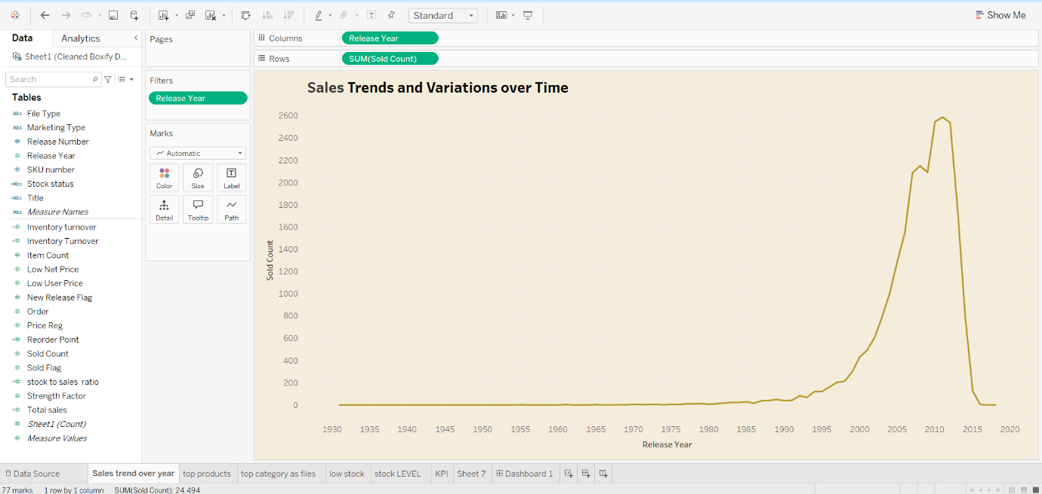

* 1. **Identify top-selling products and categories.**

* 1. **Investigate stock levels and low-stock items.**

* **Highlight insights through well-designed graphs and charts.**

**Inventory metrics (key performance indicators (e.g., inventory turnover, stock-to-sales ratio, reorder points and total sales)). Using visualization**

1. Documentation and Reporting:

* **Summarize the findings, inventory-driven insights, and recommendations from the analysis.**

**Summary of Findings**

1. **Sales Trends: Seasonal patterns and peak demand periods were identified, aiding in planning for sales fluctuations.**
2. **Top-Selling Products: Key revenue-generating products were highlighted, with significant contributions from specific categories.**
3. **Inventory Efficiency: Uneven stock distribution was revealed, with some items overstocked and others prone to stockouts.**
4. **Inventory Turnover: Turnover rates indicated areas where inventory was moving too slowly, tying up capital.**

**Inventory-Driven Insights**

1. **Stock Balancing: Identified products requiring increased stock levels to avoid lost sales and others needing reductions to lower holding costs.**
2. **Demand Forecasting: Analysis of historical trends provided accurate predictions for future inventory needs.**
3. **Category Performance: Focused on categories driving the highest revenue and profitability for targeted investments.**
4. **Aging Inventory: Highlighted items at risk of obsolescence, prompting timely clearance actions.**

**Recommendations**

1. **Reorder Strategies: Implement dynamic reorder thresholds based on historical and forecasted demand trends.**
2. **Promotional Strategies: Drive sales for slow-moving inventory through targeted promotions or bundling offers.**
3. **Inventory Audits: Regularly monitor stock levels and turnover to address inefficiencies proactively.**
4. **Data-Driven Decisions: Leverage analytics tools to continuously track and refine inventory management practices.**

* **Explain how the inventory-focused insights can benefit businesses in enhancing inventory management.**

1. **Optimized Stock Levels:  
   By identifying overstocked and understocked items, businesses can adjust inventory levels to meet demand efficiently. This reduces holding costs and avoids stockouts, ensuring that the right products are available at the right time.**
2. **Improved Demand Forecasting:  
   Historical sales trends and demand patterns provide accurate predictions for future needs. This helps businesses prepare for peak seasons, prevent over-purchasing, and streamline procurement strategies.**
3. **Faster Turnaround:  
   Insights into slow-moving inventory allow businesses to implement clearance strategies, freeing up storage space and capital for more profitable products.**
4. **Reduced Waste:  
   Addressing aging inventory and products nearing obsolescence minimizes write-offs, particularly for perishable goods or fast-changing markets like fashion or technology.**
5. **Enhanced Profitability:  
   By focusing on high-margin and top-performing products, businesses can prioritize stocking items that contribute the most to revenue and profitability.**
6. **Cost Efficiency:  
   Inventory-driven insights reduce expenses related to overstocking, understocking, and emergency restocking, allowing businesses to allocate resources more effectively.**
7. **Customer Satisfaction:  
   Maintaining optimal stock levels ensures that customers find the products they need, leading to improved trust, loyalty, and repeat business.**
8. **Real-Time Adaptability:  
   Utilizing these insights alongside analytics tools enables businesses to react quickly to market changes, optimizing inventory strategies dynamically.**

**Overall Benefit**

**By leveraging these insights, businesses can align their inventory management processes with operational goals, achieving a balance between cost efficiency, customer satisfaction, and profitability. This ultimately strengthens their competitive advantage in the market.**

**Utilized advanced visualization tool like Tableau for interactive visualizations.**

